Wave diagram 1:

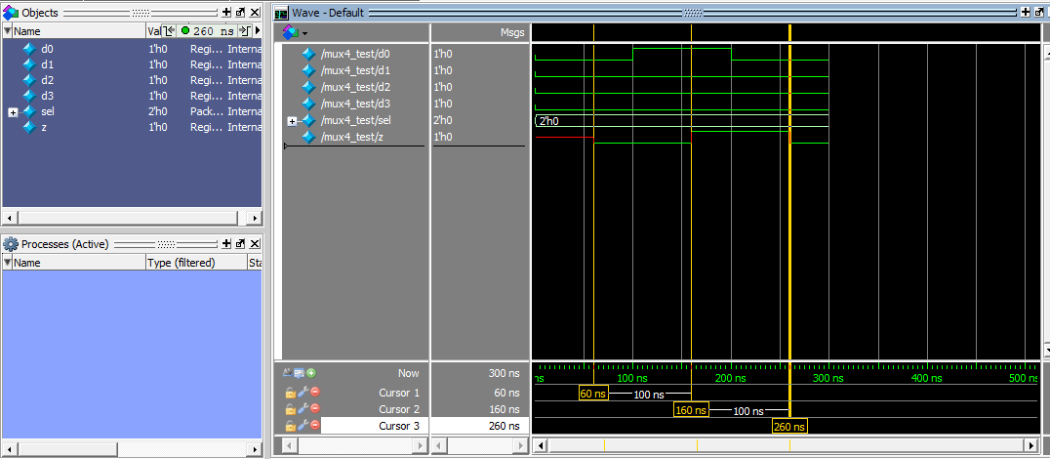

We started the simulation with the value 0 assigned to all the registers except for z, which explains the register z having the value of x at the beginning of the simulation

We changed the values every 100 ns

After 60 ns, we see that the calculations ended and z has received the value of 0, we also see that the time taken for the calculations (60 ns) matches our previous calculations

After 100 ns we changed the value of d0 to ‘1’, again the value of z only changed 60 ns after duo to calculations and again 100 ns after that we changed d0 back to the value of ‘0’ and z changed 60 ns after

Wave diagram 2:

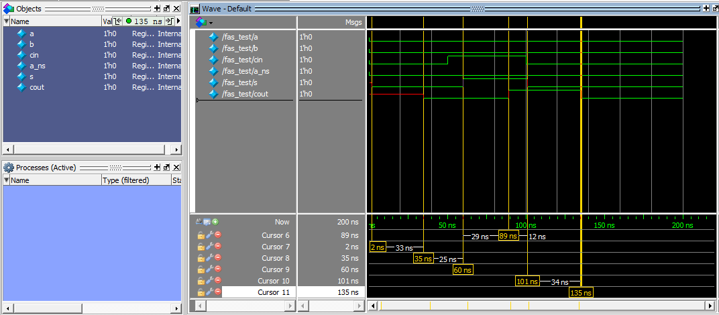

We started the simulation with the value 0 assigned to all the input registers, and changed the values every 50 ns

After 2 ns we see that the register S stabilize at value 0, the 2 ns delay might come from the fact that the simulator gave the value 1 to the register s and the internal logic so the tpd was in fact tpdHL  for both XOR gates

This seems to be the case also for Cout for we see that the value stabilizes after 35ns which is the tpd we calculated for the change from ‘1’ to ‘0’

After 50 ns we changed the input value of Cin to ‘1’, and as we calculated S stabilizes after 10 ns and Cout after 39 ns

Again after 50 ns from that we changed the value of Cin back to ‘0’, this time S stabilizes after 1 ns which is tpdHl for one XOR gate and Cout stabilizes after 35ns as we explained earlier

Wave diagram 3:

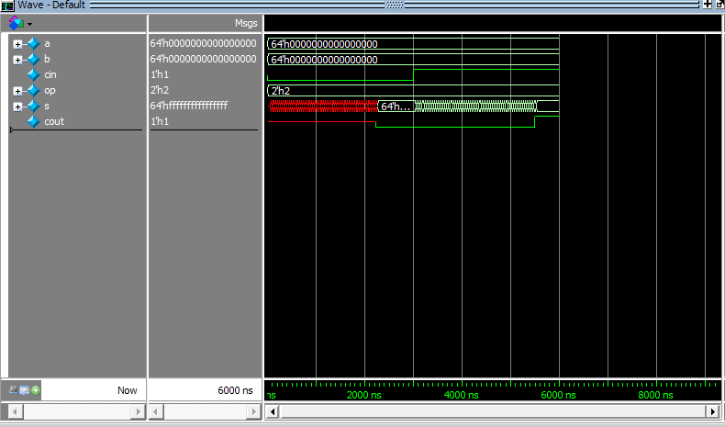

We started the simulation with the value 0 assigned to all the input registers, and with s and cout uninitialized which explains the x value at the start

For this simulation we choose to let it run for 3000ns before changing the value of cin from ‘0’ to ‘1’ in order to get the maximum tpd

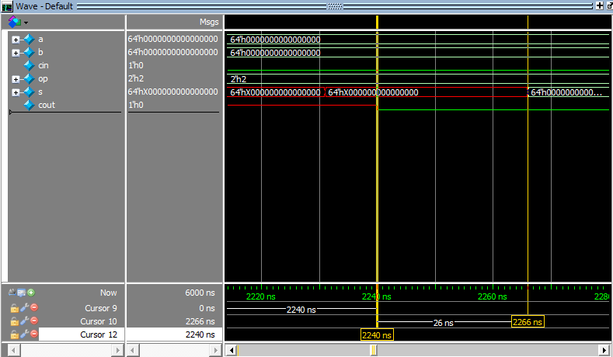

After 2240 ns the value of cout stabilizes at ‘0’ and after 2266 ns the values of the vector s all stabilize to ‘0’

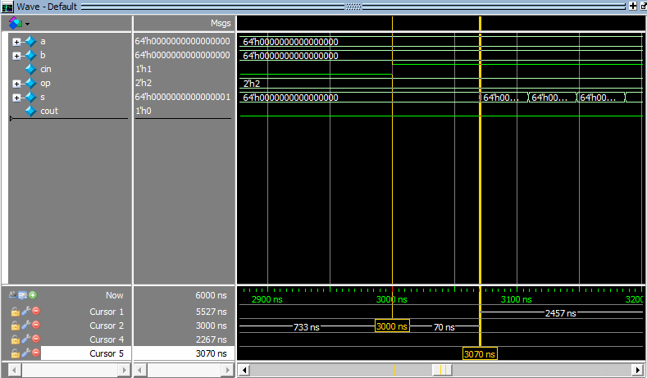

At 3000 ns we changed the value of cin to ‘1’, soon after at 3070 ns 70 ns after we changed the value the first value of s stabilizes which matches our calculation

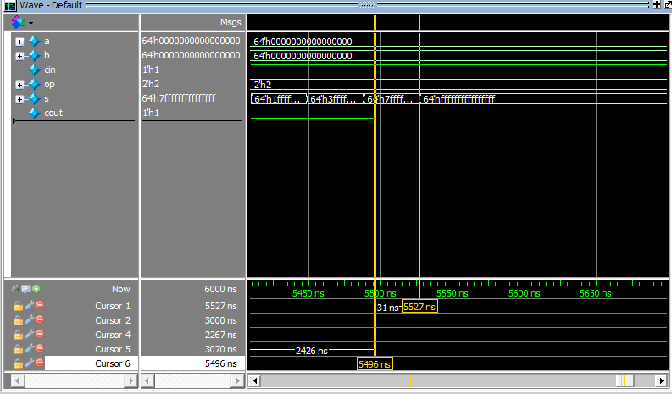

Here we can see that the value of cout updates at 5496 ns meaning after 2469 ns and the value of s updates after 2527 ns which matches our calculations

